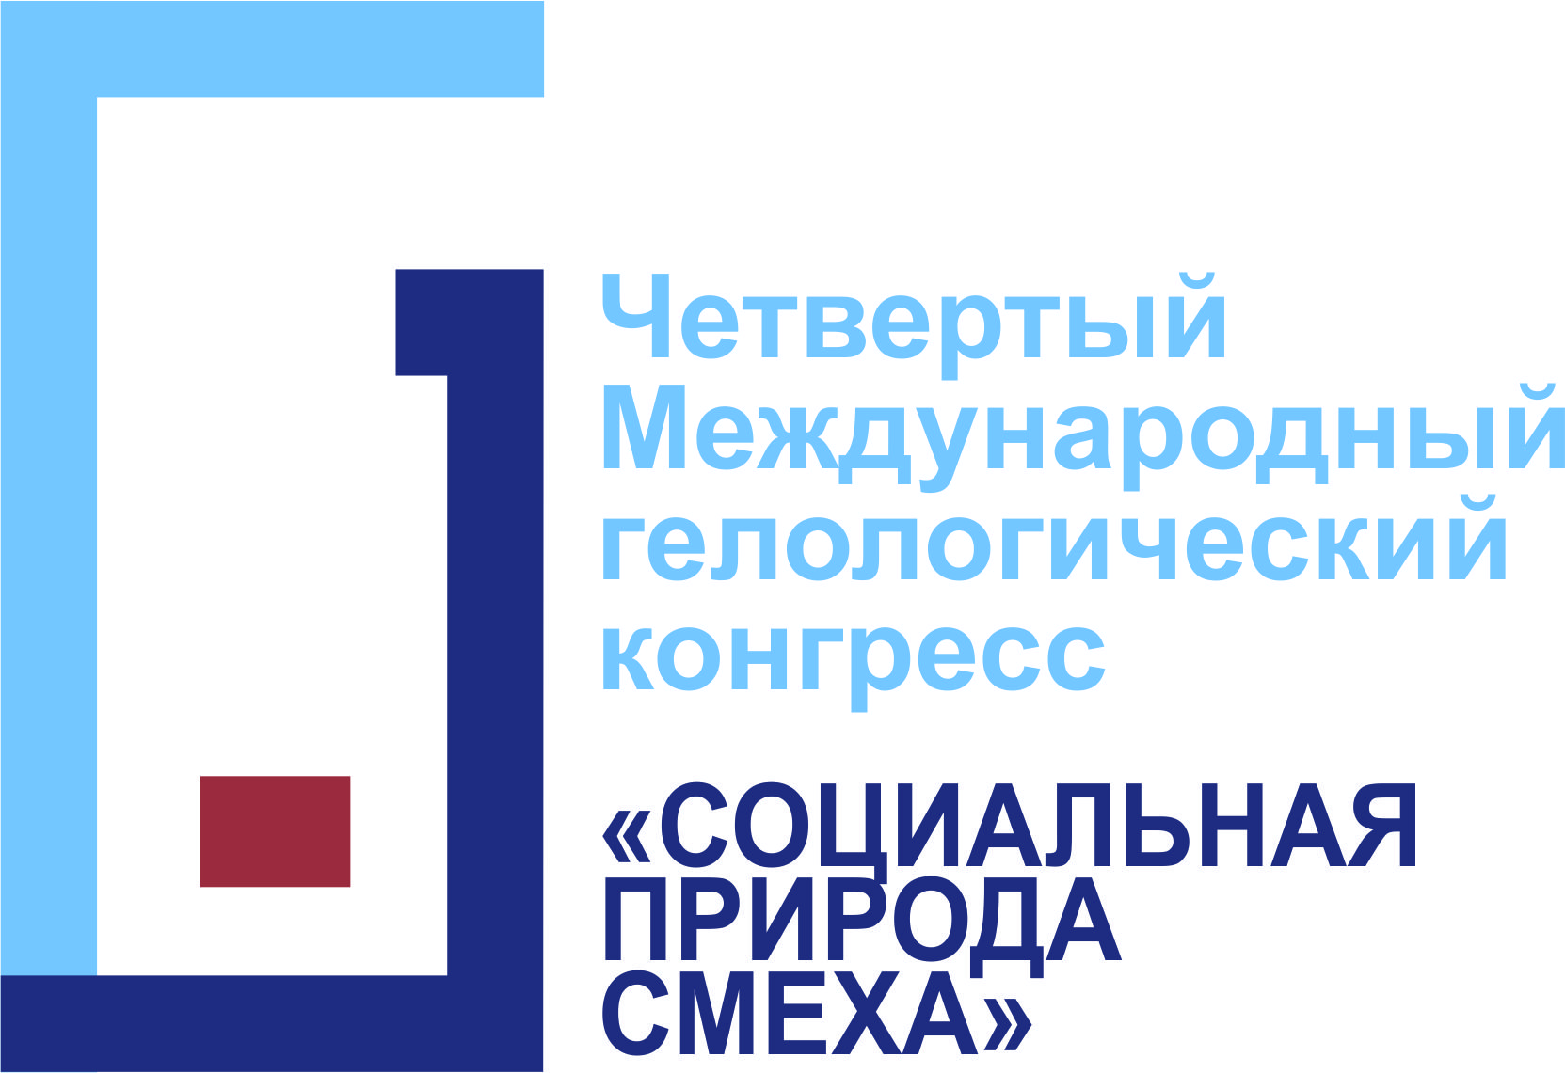
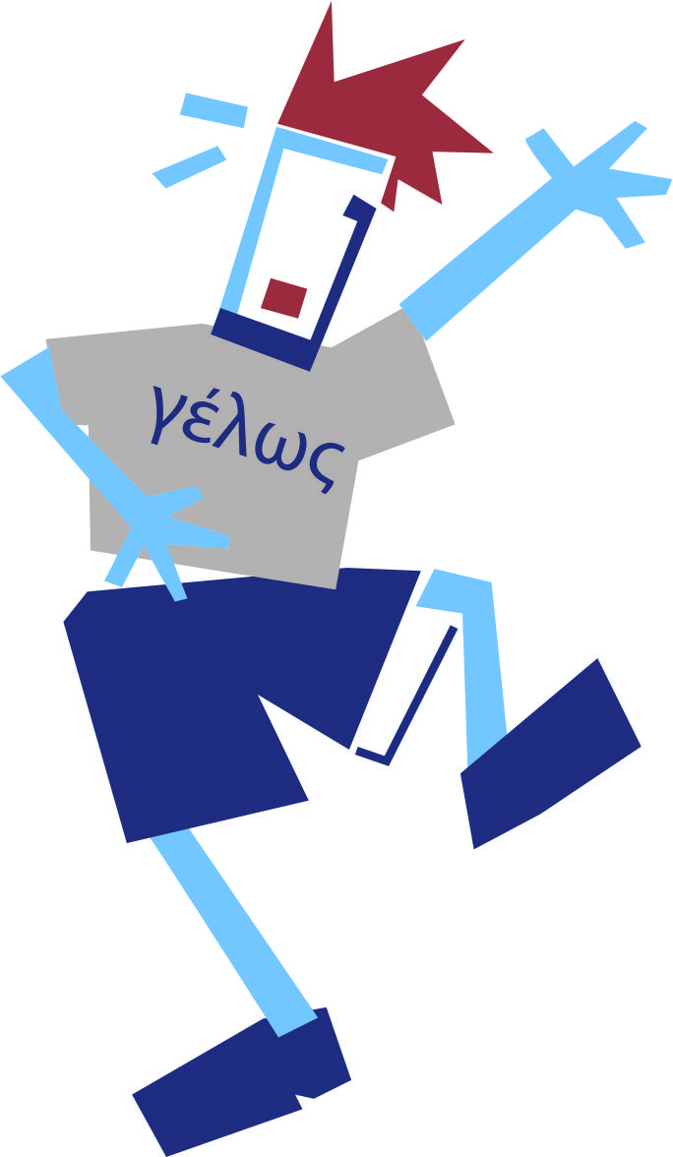
The Information Letter

Sociological institute, Russian Academy of Sciences
Research Center for Cultural Exclusion and Borderland Areas

Saint Petersburg State University
Institute of Philosophy
Department of Russian philosophy and culture stadies

Mental Health Research Center (Moscow, Russia)

Non-profit charitable organization «Odessa humanitarian tradition» (Odessa, Ukraine)

Agency «Mice and Travel»

St. Petersburg State Clown–Mim-Theatre “Mimigrants”.

The 25th-27th May 2017 conduct

The 4rd International Gelological Congress

«SOCIAL NATURE of LAUGHTER»
During the congress it is planned to focus on the social aspects of laughter, social genesis of laughter, fear of laughter, bulling, tomfoolery, communicative aspects of laughter. Sociologists, social philosophers, psychologists, sociolinguists and others are invited to participate.
Time-limit
Oral presentation – up to 25 min
Discussion - up to 10 min

Within the congress are also planned
- Round table discussions
- Work-shops
- Seminars
- Social program

Organizing committee:
Prof. Brodsky A. (SPbSU)
Prof. Golovin V. (IRL of RAS)
Dr. Enikolopov S. (MHRC)
Dr. Ivanova A. (MHRC) – co-chairman
Prof. Kozintsev A. (MAE of RAS)
Dr. Laineste L. (Estonian Literary Museum, Centre of Excellence for Estonian Studies (CEES), Estonia)
Dr. Levchenko V. (Mechnikov’s ONU, Ukraine)
Dr. Makovetsky E. (SPbSU)
Prof. Malinov A. (SPbSU)
Dr. Nikolaeva Zh. (SPbSU)
Dr. Ovchinnikova E. (SPbSU)
Dr. Platt T. (University of Wolverhampton, UK)
Plush-Nezhinsky A. (St. Petersburg State Clown–Mim-Theatre “Mimigrants”)
Dr. Radeev A. (SPbSU)
Dr. Troitckii S. (SPbSU) - chairman

APPLICATION TO THE CONFERENCE:
To participate in the conference it is necessary to send to the organizing committee:
- registration information (name, surname, affiliation, position, e-mail, contact telephone number)
- title of the paper
- abstract (up to 1000 characters) or text of the paper (up to 1 author’s sheet or 40000 characters) in Russian or English the deadline is the 1st of February 2017
The organizing committee suggests to publish the materials of the conference. The organizing committee reserves the right of preliminary selection and editing of the received materials. The materials are not reviewed or returned. The texts and the abstracts should be sent in Word-format.
Please send the application with all the materials to: sergtroy@yandex.ru with a mark “to main sessions” or “to the round table”.

